4th Intonation Workshop

Friday, February 15, 2019
Northrop Frye Hall, 004

9:00-9:30 | Coffee & Registration
9:30-9:40 | Introduction
9:40-10:40 | Keynote
Moderator: Maria Cristina Cuervo | Michael Wagner (McGill University)  Toward a bestiary of the intonational tunes of English
10:40-11:25 | Poster Session 1
Moderator:  Shahrzad Mirzaei | It is Canadian English focus marking I’m looking at: Prosodic focus marking in clefts and unmarked statements  Anja Arnhold (University of Alberta)  Commitment and engagement: A uniform account of rises on declaratives  Johannes Heim (University of British Columbia)  The emphatic juncture in English: A novel use of the IP boundary  Bethany Sturman (University of California, Los Angeles)
11:25-11:30 | Coffee Break
11:30:12:15 | Poster Session 2
Moderator: Anabela Rato | L2 acquisition of French stress by novice Persian learners: Impact of L1 morphology  Shahrzad Mirzaei (University of Toronto)  Contact-induced intonation change in Venezuelan Spanish speakers living in Canada  Natasha Swiderski¹, Celina Valdivia¹, Yasaman Rafat¹ and Rajiv Rao² (¹Western University, ²University of Wisconsin-Madison)  Typology and the production of L2 English sentence types by Inuktitut, Mandarin and Spanish speakers  Laura Colantoni¹, Alana Johns¹, Gabrielle Klassen¹, Matthew Patience¹, Malina Radu¹ and Olga Tararova² (¹University of Toronto, ²Western University)
12:15-2:00 | Lunch
2:00-2:45 | Poster Session 3
Moderator: Meï-Lan Mamode | Are non-native speakers better at producing contrastive focus?  Hyunah Baek, Jiwon Hwang, Chikako Takahashi, Alex HL Yeung, Joseph Duncan, Sharon Benedett and Ellen Broselow (Stony Brook University)  L2 Acquisition of Nuclear Placement in English  Stephanie Landblom (University of Illinois at Urbana Champaign)  To what extent does prosodic typology influence L2 acquisition? Evidence from the L2 perception-comprehension of English sentence types  Laura Colantoni¹, Alana Johns¹, Gabrielle Klassen¹, Matthew Patience¹, Malina Radu¹ and Olga Tararova² (¹University of Toronto, ²Western University)
2:45-3:45 | Poster Session 4
Moderator:  Olivia Marasco | Are Focus and Givenness Prosodically Marked in Kinyarwanda and Rwandan English?  Fatima Hamlaoui¹, Jonas Engelmann² and Kriszta Szendroi³ (¹University of Toronto, ²Leibniz-ZAS, ³UCL)  Narrow focus prosody in Kazan Tatar  Adam Royer and Sun-Ah Jun (University of California, Los Angeles)  A phonetic study of the relation between subglottal pressure and intonation in French declarative sentences  Ruolan Wang¹, Sergio Hassid² and Didier Demolin¹  (¹Laboratoire de phonétique et phonologie, UMR 7018, Sorbonne nouvelle, Paris 3, ²Hôpital Erasme, Université Libre de Bruxelles)  Post-focus prosodic asymmetry in spoken Cantonese  Ivan Chow¹, Michel Belyk², Samson Yeung³ and Steven Brown³  (¹University of Toronto Mississauga, ²Bloorview Research Institute, ³McMaster University)
3:45-4:00 | Coffee break
4:00-5:00 | Keynote speaker
Moderator:  Vanina Machado | Sun-Ah Jun (University of California, Los Angeles)  The goal of focus prosody is to violate rules of language-specific default prosody

The goal of focus prosody is to violate
rules of language-specific default prosody
Sun-Ah Jun
University of California, Los Angeles

Focus prosody is a prosodic mechanism used to mark focus. The most well-known focus prosody across languages is to increase/expand pitch range (also likely increase duration and intensity) of the focused item, especially on the head syllable of the word, and decrease/compress the pitch range (and duration and intensity) of post-focus (and pre-focus, to a lesser degree) items. Thus, the goal of focus prosody seems to make the focused word the most prominent in a phrase by manipulating suprasegmental properties: Sudden rises in spoken f0 is perceptually more salient than falling f0 (Hsu, Evans, & Lee 2015), and speakers use higher f0 when producing words with increased emphasis (Liberman & Pierrehumbert 1984). This goal can also be achieved by manipulating the prosodic structure of a sentence. That is, some languages mark focus by deleting a prosodic boundary after a focused item and/or inserting a new boundary before a focused item, thus making the focused item the first or the last prominent item in a phrase.

However, focus data from various languages suggest that a low f0 is also used to mark a word prominent (e.g., yes/no-questions in English and Greek; formal speech in Mongolian) and prominence of a focused item can also be marked by its non-head syllable (e.g., French, Tatar) or the word immediately preceding or following the focused word (e.g., Turkish, Kyungsang Korean). Therefore, the mechanism of making a word prominent is not necessarily targeting the perceptual salience of high f0 on the focused word. Instead, the goal of focus prosody, i.e., making the focused word prominent, seems to be achieved by violating the language-specific rule of default prosody. It can violate the mapping between syntactic phrase and prosodic phrase (Selkirk 2011), or violate the tonal affiliation rule (to the head or the edge of a word), or avoid using the tonal categories or their phonetic realizations found in the default prosody of the sentence produced in the neutral focus condition.

This talk will present data from Turkish where a focused word is realized in a reduced pitch range on the focused word while expanding pitch range on the preceding word. It will also present data from the Yanbian dialect of Korean, a lexical pitch accent language spoken in northeastern China, adjacent to North Korea, where a focused word can be marked by non-default phrasing or by a low tone on the word-initial syllable (not necessarily the head of the focused word) when the word is immediately preceding a head noun of a heavy syntactic structure (Jun & Jiang 2018). These mechanisms will be discussed by referring to the goal of enhancing prominence.

References
Hsu, C.-H., Evans, J. P., & Lee, C.-Y. (2015) Brain responses to spoken F0 changes: Is H special? J. of Phonetics 51: 82-92.
Jun, S.-A. & Jiang, X. (2018) Differences in prosodic phrasing in marking syntax vs. focus: Data from Yanbian Korean. The Linguistic Review. https://doi.org/10.1515/tlr-2018-2009.
Liberman, M. & Pierrehumbert, J. (1984) “Intonational invariance under changes in pitch range and length,” in M. Aronoff & R. Oerhle (eds.) Language sound structure. MIT Press, pp.157-233.
Selkirk, E. (2011). The syntax-phonology interface. In John Goldsmith, Jason Riggle, and Alan Yu (Eds.) The Handbook of Phonological Theory, 2nd edition (pp. 435-84). Oxford: Blackwell Publishing.

Toward a Bestiary of the Intonational Tunes of English
Michael Wagner
McGill University

What is the inventory of tunes of North American English? What do particular tunes contribute to the pragmatic and semantic import of an utterance? How reliably are certain conversational goals and intentions associated with the use of particular tunes? While English intonation is well-studied, the answers to these questions still remain preliminary. We present the results of scripted experiments that complement existing knowledge by providing some data on what tunes speakers use to accomplish particular conversational goals, and how likely particular choices are. This research complements studies of the meaning and form of individual contours, which often does not explore the alternative prosodic means to achieve a certain conversational goal; it also complements more exploratory research based on speech corpora, which offer a rich field for exploring which contours are generally out there, but since the context often underdetermines the real intentions of the speaker, they make it hard to come to firm conclusions with respect to the contribution of particular tunes.

Our studies focus on three types of conversational goals, the goal to contradict (‘Intended Contradiction’), to imply something indirectly (‘Intended Implication’), or to express incredulity (‘Intended Incredulity’). We looked at these three intents since their expression has been linked in the prior literature with the use of three particular rising contours: the Contradiction Contour (Liberman & Sag, 1974; Ladd, 1980; Ward & Hirschberg, 1985; Goodhue & Wagner 2018)), the Rise-Fall-rise Contour (Ward & Hirschberg, 1985; Constant, 2012; Wagner, 2012; ), and the incredulity contour (Hirschberg & Ward, 1992).

Our results show that participants indeed use the expected contours more frequently than others to achieve the respective conversational goals---except that they almost never used the Incredulity Contour. To convey incredulity, speakers almost always chose the Polar Question Rise (Pierrehumbert & Hirschberg, 1990, Bartels, 1999; Truckenbrodt 2012). In Contradictions, there was more variability in the choice of intonational tune than with the other two intents. When speakers did not use the Contradiction Contour, they often contradicted the interlocutor using a Declarative Fall with Polarity Focus, or a hitherto undescribed falling contour, which we label the Presumption Contour. Our results also show an interesting interaction between choice of tune and focus prominence (Goodhue & Wagner 2016; cf. Schlöder 2018). We discuss the challenge such interactions pose for Rooth's alternatives theory of focus, and how one might go about addressing it.

It is Canadian English focus marking I am looking at: Prosodic focus marking in clefts and unmarked statements
Anja Arnhold
University of Alberta

Canadian English prosody is often, implicitly or explicitly, assumed to be similar to American English, though with some similarities to British English (e.g. Dodds de Wolf, 1992), or taken to be representative of (North American) English more generally (e.g. Goodhue et al., 2015; Wagner & McAuliffe, 2017). However, some studies report prosodic patterns specific to Canadian English, in particular the realization of uptalk (James et al., 1989; Shokeir, 2008; Talla Sando, 2009; Halford, 2009). Based on two experiments, this presentation highlights some idiosyncrasies of prosodic focus marking in Canadian English.
First, 28 participants (aged 18-43; 7 male; all native Canadian English speakers) produced cleft sentences and sentences with unmarked syntax in broad and narrow subject focus contexts (e.g. BF What happened next? vs. NF Who rewarded the waiter? for the unmarked target The owner rewarded the waiter; 36 target trials + 15 fillers per participant). Linear mixed-effects modelling (Baayen et al., 2008) of 910 analyzable sentences failed to find the raised peaks and consistently expanded pitch range reported to mark narrow focus in American English (e.g. Breen et al., 2010), but instead showed that pitch peaks were significantly earlier in narrow than in broad focus (Fig. 1).
Second, 230 participants in a perception study (aged 17-45; 59 male; native Canadian English speakers) rated the same cleft and unmarked sentences spoken with prosody typical of broad and narrow subject focus by a female speaker from Alberta (average f0 contours very similar to Fig. 1), presented in the broad and narrow focus contexts from the production study (2x2x2 design crossing the factors syntax, prosodic focus marking and context). Each participant encountered each of the 24 target sentences in only one condition (+36 fillers). The 5485 usable data points indicated that listeners were able to differentiate sentences with and without prosodically marked narrow focus, but this difference was only significant in broad focus contexts (Fig. 2).
While these results suggest crucial differences between Canadian English and American English, the source of these differences is so far unclear. They could indicate that Canadian English uses its own set of pitch accent categories for marking information structure, which differs from the accent inventory of American English. Additionally, prosodic focus marking could be somewhat optional in Canadian English.
Finally, in addition to the prosodic distinctiveness of Canadian English, the poster will discuss the interaction between prosody and the use of cleft sentences in focus marking.

Figures
Fig. 1: Average f0 contours and standard error for 3 conditions in production study. Note that clefts never appeared in broad focus (infelicitous context). |  | Fig. 2: Results of perception study. Clefts did appear in broad focus here.
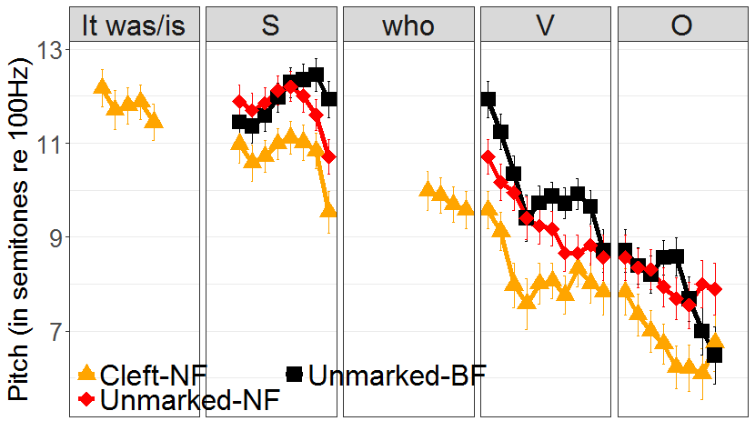 |  | 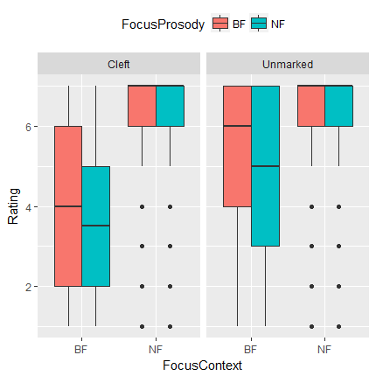

References
Baayen, R. H., Davidson, D. J., & Bates, D. M. (2008). Mixed-effects modeling with crossed random effects for subjects and items. Journal of Memory and Language, 59(4), 390–412. http://doi.org/10.1016/j.jml.2007.12.005
Breen, M., Fedorenko, E., Wagner, M., & Gibson, E. (2010). Acoustic correlates of information structure. Language and Cognitive Processes, 25, 1044–1098. http://doi.org/10.1080/01690965.2010.504378
Dodds de Wolf, G. T. (1992). Social and regional factors in Canadian English: A study of phonological variables and grammatical items in Ottawa and Vancouver. Toronto: Canadian Scholar’s Press.
Goodhue, D., Harrison, L., Siu, Y. T. C., & Wagner, M. (2015). Toward a bestiary of English intonational contours. In C. Hammerly & B. Prickett (Eds.), Proceedings of the 46th Conference of the North Eastern Linguistic Society (NELS) (pp. 311–320). Concordia University.
Halford, B. K. (2007). Adolescent intonation in Canada: Talk units in in-group conversations. Anglia, 125(1), 4–30. http://doi.org/10.1515/ANGL.2007.4
James, E., Mahut, C., & Latkiewicz, G. (1989). The investigation of an apparently new intonation pattern in Toronto English. Information Communication, 10, 11–17.
Shokeir, V. (2008). Evidence for the stable use of uptalk in South Ontario English. University of Pennsylvania Working Papers in Linguistics, 14(2), 16–24.
Talla Sando, Y. (2009). Upspeak across Canadian English accents: Acoustic and sociophonetic evidence. In Proceedings of the 2009 nnual conference of the Canadian Linguistic Association (pp. 1–12).
Wagner, M., & McAuliffe, M. (2017). Three dimensions of sentence prosody and their
(Non-)Interactions. In Proceedings of the Annual Conference of the International Speech Communication Association, INTERSPEECH (pp. 3196–3200). Stockholm. http://doi.org/10.21437/Interspeech.2017-1500

Are non-native speakers better at producing contrastive focus?
Hyunah Baek, Jiwon Hwang, Chikako Takahashi, Alex HL Yeung, Joseph Duncan,
Sharon Benedett, Ellen Broselow
Stony Brook University

This study reports on a comparison of the production of contrastive focus by native English speakers (ES) and L2 English-Mandarin speakers (MS). We found that the cues used to realize focus varied by sentence position for native English speakers but not Mandarin speakers. We argue that this variation in the ES’ production of contrastive focus reflects an innovative intonation pattern, which is not found in the production of the non-native speakers.

Two groups of participants, 23 ES and 25 MS, played an interactive game in which participants instructed the experimenter to decorate items belonging to two characters called Andy and Mindy. The decorations consisted of three shapes (arrow, diamond, oval) in three colors (navy, orange, yellow), all consisting of bisyllabic trochees. All elicited sentences (e.g., Andy wants an orange diamond on his towel and a NAVY diamond on Mindy’s towel) involved placement of two decorations contrasting either in color (adj-contrast) or in shape (n-contrast).

To determine the pitch and intensity of the second noun phrase in each sentence, phrases were segmented word-by-word by hand in Praat (Boersma & Weenink 2011), and time-normalized pitch and intensity contours were extracted using ProsodyPro (Xu 2013). English focus is generally described as alignment of L+H* with the stressed syllable of the focused word. The preliminary results (9 MS and 10 ES) show that for adjective focus, both MS and ES show the expected pattern of F0 peak on the first syllable, followed by a drop in F0 (Fig. 1 - 4). For noun focused items, however, the two groups showed markedly different pitch patterns. While the MS showed the expected peak on the focused noun, ES showed the pitch peak on the adjective with a steady decline throughout the noun. ES did, however, showed an increase in intensity on the focused noun, as did MS. We argue that the ES’s failure to realize an L+H* pitch accent on focused nouns reflects their use of innovative intonation patterns which have been noted among younger female speakers, in which sentence final position is associated with vocal fry (Wolk et al. 2012). In this pattern, the primary cue for focus on words in sentence final position is intensity rather than F0.

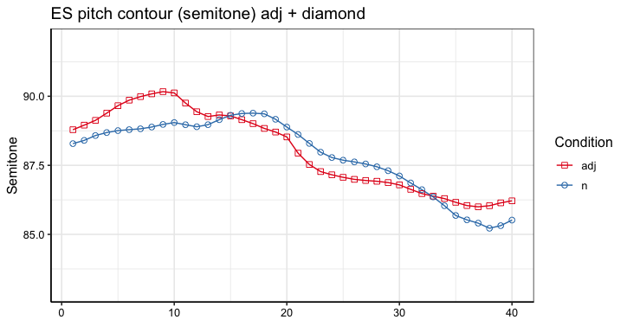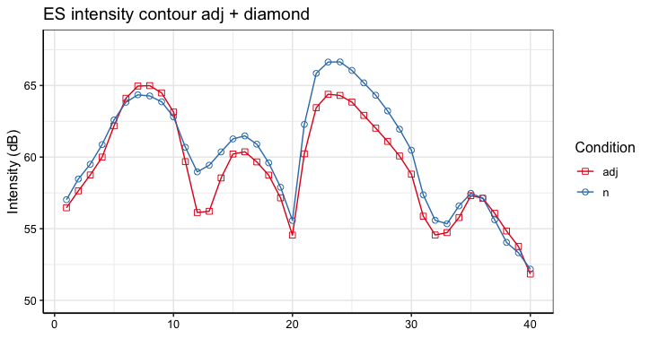
Fig. 1 (left) and 2 (right), English Speakers’ pitch (left) and intensity (right) contour of adjective + diamond in adjective and noun focused conditions.

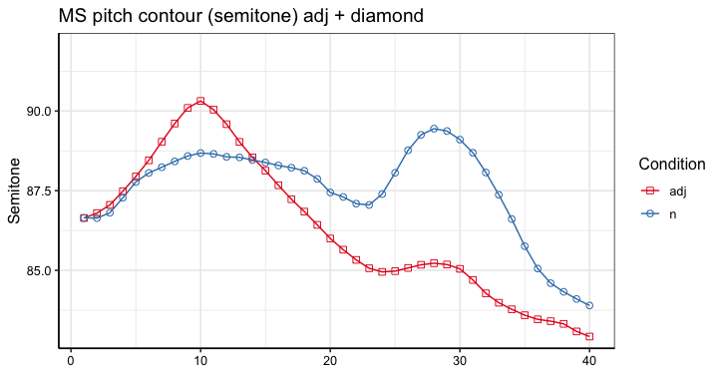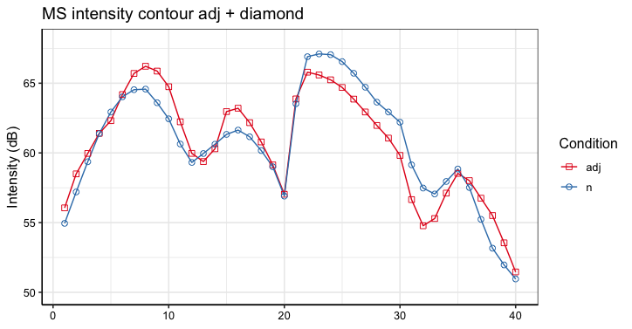
Fig. 3 (left) and 4 (right) Mandarin Speakers’ pitch (left) and intensity (right) contour of adjective + diamond in adjective and noun focused conditions

References
- Boersma, Paul & David Weenink. 2011. Praat: Doing Phonetics by Computer. Ear and Hearing, 32(2). 266. https://doi.org/10.1097/aud.0b013e31821473f7.
- Wolk, Lesley, Nassima B. Abdelli-Beruh, & Dianne Slavin. 2012. Habitual Use of Vocal Fry in Young Adult Female Speakers, Journal of Voice 26(3). e111-e116.
- Xu, Yi. 2013. ProsodyPro - A Tool for Large-scale Systematic Prosody Analysis. In Proceedings of Tools and Resources for the Analysis of Speech Prosody (TRASP 2013), Aix-en-Provence, France. 7-10.

Post-focus prosodic asymmetries in spoken Cantonese
Ivan Chow¹, Michel Belyk², Samson Yeung³, Steven Brown³
¹University of Toronto Mississauga, ²Bloorview Research Institute, ³McMaster University

Narrow focus refers to the marking of a specific component of an utterance as more salient than the rest [1]. Prosodic studies of narrow focus indicate the use of increase in intensity, syllabic duration and higher pitch to highlight the on-focus component [2-7]. In addition to on-focus effects, “post-focus compression” (PFC) is also observed in Mandarin and Cantonese [6-8]: the post-focus component is marked with reduced pitch range and intensity. The present study sets out to examine the acoustic changes in post-focus syllables in spoken Cantonese. Results indicate significant reduction of intensity and lowering of average pitch in post-focus syllables; non-initial syllables in prosodic feet are also significantly shortened in post-focus positions. However, the effects of PFC on pitch range seems to be marginal.

[1] Eady, S. J., Cooper, W. E., Klouda, G. V., Mueller, P. R., & Lotts, D. W. (1986). Acoustical characteristics of sentential focus: Narrow vs. broad and single vs. dual focus environments. Language and speech, 29(3), 233-251.
[2] Baumann, S., Grice, M., & Steindamm, S. (2006). Prosodic marking of focus domains-categorical or gradient. In Proceedings of Speech Prosody, 301-304.
[3] Frota, S. (2014). Prosody and focus in European Portuguese: Phonological phrasing and intonation. Routledge.
[4] Hanssen, J. E. G., Peters, J., & Gussenhoven, C. (2008). Prosodic effects of focus in Dutch declaratives. In Proceedings of Speech Prosody, 609-612.
[5] Selkirk, E. (1995). Sentence prosody: Intonation, stress, and phrasing. The handbook of phonological theory, 1, 550-569.
[6] Wu, W. L., & Xu, Y. (2010). Prosodic focus in Hong Kong Cantonese without post-focus compression. In Proceeding of Speech Prosody, 100040:1-4.
[7] Xu, Y. (1999). Effects of tone and focus on the formation and alignment of f0contours. Journal of phonetics, 27(1), 55-105.
[8] Chen, Y. (2010). Post-focus F0 compression—Now you see it, now you don’t. Journal of Phonetics, 38(4), 517-525.
[9] Bates, D., Maechler, M., Bolker, B., & Walker, S. (2015). Fitting linear mixed-effects
models using lme4. Journal of Statistical Software, 67(1), 1–48.
[10] Core Team (2017). R: A language and environment for statistical computing.
Vienna, Austria: R Foundation for Statistical Computing. Retrieved from http://cran.r-project.org/

Typology and the production of L2 English sentence types by
Inuktitut, Mandarin and Spanish speakers
Laura Colantoni¹, Alana Johns¹, Gabrielle Klassen¹, Matthew Patience¹,
Malina Radu¹, and Olga Tararova²
¹University of Toronto, ²Western University

Cross-linguistic influence (CLI) is one of the most researched themes in L2 acquisition and prosody is not an exception. However, it is still not clear to what extent prosodic typology allows us to make general rather than structure-by-structure predictions regarding the acquisition of intonational contours. Moreover, studies have pointed out that CLI interacts with task type in modelling L2 speakers’ production [1]. Thus, we explore both the role of CLI and task type in the production of English statements (Ss), absolute questions (AQs), and declarative questions (DQs) by L1 speakers of Inuktitut, Spanish and Mandarin. In English, AQs are syntactically and prosodically marked, whereas the difference between Ss and DQs is purely prosodic. In contrast, Spanish only uses intonation to distinguish statements from AQs and DQs [2]. In Mandarin, both questions can either be syntactically identical to statements or they can be marked by the lexical particle –ma [3,4]. Contrary to Mandarin, English, and Spanish, Inuktitut has a very restricted use of pitch. Statements and questions are morphologically marked (Indicative vs. Interrogative mood; [5], [6]), and, while pitch can optionally be used with lengthening to mark interrogative utterances [7], it primarily signals that the speaker has not finished speaking. Based on expectations from CLI and what is known about the prosody of the three languages, we predicted that Inuktitut speakers would be outperformed by the other groups. Additionally, based on recent experimental work, bilinguals should differ from controls to a larger extent in contextualized than decontextualized tasks [1].

To test these hypotheses, Canadian English controls (N=15), L1 Spanish (N=15), L1 Mandarin (15 per group) and L1 Inuktitut (N=13) learners of L2 English performed a sentence imitation task (10 stimuli x sentence type + distractors) and a contextualized production task (6 scenarios per sentence type). We labeled the first pitch accent and the final nuclear contour, and calculated the pitch change in semitones. Results revealed differences across groups in the pitch excursion in the sentence imitation task (significantly smallest change was observed in Spanish speakers, followed by Inuktitut and Mandarin speakers) and differences between Mandarin learners and controls in the realization of nuclear contours in statements. All groups had smaller pitch changes in the contextualized production than in the sentence imitation task. However, against our prediction, Inuktitut speakers outperformed the other two groups in the latter task, differing significantly from Spanish and Mandarin speakers who had a higher proportion of non-target realizations in the contextualized production task (AQs were used in contexts where DQs were expected). These results suggest that the Inuktitut speakers have acquired the distribution of sentence types, but still differ prosodically from controls, whereas the other two groups differ both in the distribution of questions types and in the realization of pitch accents (both groups) and nuclear contours (Mandarin group). We will discuss these results taking into account the nature of the input to which each group was exposed.

References

[1] Ortega-Llebaria, M., & Colantoni, L. (2014). The L2 acquisition of English intonation: Relations between form-meaning associations, access to meaning and L1 transfer. Studies in Second Language Acquisition, 36(2), 331-353.
[2] Hualde, J. I. (2005). The Sounds of Spanish. Cambridge, UK: Cambridge University Press.
[3] Li, C. N., & Thompson, S. (1981). Mandarin Chinese: A Functional Reference Grammar. Berkeley, CA: University of California Press.
[4] Lee, O. J. (2005). The Prosody of Questions in Beijing Mandarin. PhD Dissertation. Ohio State University.
[5] Spalding, A.E. (1969). Salliq: An Eskimo Grammar. Ottawa: Education Branch, Department of Indian Affairs and Northern Development.
[6] Smith, L. (1977). Some Grammatical Aspects of Labrador Inuttut (Eskimo): A Survey of the Inflectional Paradigm of Nouns and Verbs. Ottawa, National Museum of Canada.
[7] Shokeir, V. (2009). Intonation in Inuktitut. Master’s Thesis. University of Toronto.

To what extent does prosodic typology influence L2 acquisition? Evidence from the perception-comprehension of L2 English sentence types
Laura Colantoni¹, Alana Johns¹, Gabrielle Klassen¹, Matthew Patience¹,
Malina Radu¹, and Olga Tararova²
¹University of Toronto, ²Western University

Recent research on the acquisition of intonation has revealed that L2 speakers show greater effects of L1 influence in contextualized tasks than in tasks that target isolated or low-pass filtered utterances. However, such research has focused on a limited number of languages and structures. Our goal is to contribute to this line of research by investigating the role of context and L1 influence in the perception and comprehension of L2 English sentence types (statements (Ss), absolute questions (AQs) and declarative questions (DQs)) by speakers of three typologically different languages: Spanish, Mandarin, and Inuktitut.

In English, AQs are syntactically and prosodically marked, whereas the difference between Ss and DQs is purely prosodic. In contrast, Spanish only uses intonation (a final rising boundary tone) to distinguish statements from AQs and DQs [1]. In Mandarin, questions (AQs and DQs) can either be syntactically identical to statements or they can be marked by the lexical particle –ma [2,3]. In contrast to Mandarin, English, and Spanish, Inuktitut has a very restricted use of pitch. Statements and questions are morphologically marked (Indicative vs. Interrogative mood; [4], [5]), and while pitch can optionally be used with lengthening to mark interrogative utterances [6], it is primarily used to indicate that the speaker has not finished talking. Based on cross-linguistic comparisons, we predict that the Inuktitut group should be outperformed by the other groups. Moreover, based on recent experimental work, we expect that bilinguals will differ from controls to a larger extent in contextualized compared to decontextualized tasks.

To achieve our goal we compared Canadian English controls (N=15) to L1 Spanish (N=15), L1 Mandarin (N=15), and L1 Inuktitut (N=13) advanced L2 learners of English across three perception tasks: a low-pass filtered sentence identification task (Task 1), a decontextualized sentence identification task (Task 2) and a matching task (a context with three possible answers) (Task 3). Mean accuracy rates per language group were calculated and hypotheses were evaluated using binomial mixed effects models.

Results revealed a complex interaction of cross-linguistic influence and task-effects. Bilinguals did not differ from controls when listening to low-pass filtered utterances (Task 1). However, all groups differed from controls in the other two tasks. When presented with isolated DQs (Task 2), L1 Mandarin speakers labeled them as either exclamations or Ss. However, in Task 3, they appear to have acquired the contextual distribution of the two question types. In contrast, the other two groups more accurately identified DQs as questions in Task 2, but they performed less accurately than the Mandarin speakers when contextual information was provided (Task 3). Specifically, they tended to select AQs when the context prompted DQs. These results suggest that in context, syntax overrides prosody for L1 Inuktitut and L1 Spanish. We discuss our results in light of crosslinguistic and other learner differences.

References
[1] Hualde, J. I. (2005). The Sounds of Spanish. Cambridge, UK: Cambridge University Press.
[2] Li, Ch. & Thompson, S. (1981). Mandarin Chinese: A Functional Reference Grammar. Berkeley: University of California Press.
[3] Lee, O. J. (2005). The Prosody of Questions in Beijing Mandarin. PhD Dissertation. Ohio State University.
[4] Spalding, A.E. (1969). Salliq: An Eskimo Grammar. Ottawa: Education Branch, Department of Indian Affairs and Northern Development.
[5] Smith, L. (1977). Some Grammatical Aspects of Labrador Inuttut (Eskimo): A Survey of the Inflectional Paradigm of Nouns and Verbs. Ottawa, National Museum of Canada.
[6] Shokeir, V. (2009). Intonation in Inuktitut. Master’s Thesis. University of Toronto.

Are Focus and Givenness Prosodically Marked in Kinyarwanda and Rwandan English?
Fatima Hamlaoui¹, Jonas Engelmann², Kriszta Szendrői³
¹University of Toronto, ²Leibniz-ZAS, ³UCL

Many languages have been shown to systematically express the information-structural notion of focus (Krifka 2007). This is the case in Bantu languages too, where morpho-syntactic and/or prosodic means are used. Typically, focus has been associated with an Immediately After the Verb position (Watters 1979, Hyman 1979), with cleft-sentences (Costa & Kula 2008) or with the introduction of a prosodic phrase edge (Kanerva 1990). In Kinyarwanda, focus has been associated with the rightmost position within the clause (Kimenyi 1988). No study has yet systematically investigated whether Kinyarwanda narrow focus is also associated with specific acoustic correlates.

According to Zerbian (2015), if focus marking is a widespread phenomenon, languages however differ much more on whether they express the information-structural notion of givenness, i.e. that an expression is salient in a discourse context (Krifka 2007). Whereas Germanic languages systematically reduce post-focal given items (lower F0, intensity and duration), Romance languages do so only in some contexts (Cruttenden 2006). Acoustic and perceptual studies of both Southern Bantu languages and African English contact varieties suggest that given and non-given information is not prosodically distinguished (Zerbian 2015).

In this study, we systematically investigate the prosodic expression of both focus and post-focal givenness in 13 bilingual speakers (age 19-25) of Kinyarwanda and Rwandan English. We were interested in both the prosodic properties of our speakers’ native language (L1) and the extent to which they would transfer onto their second language (L2). We elicited semi-spontaneous speech as part of two similar production experiments, one for each language. Participants were asked to participate in a pseudo-dialogue: they were presented with a pre-recorded context for which they were asked to provide a scripted response (à la Vander Klok et al. 2018). 9 experimental items were used, consisting in 4 transitive (SVO) and 5 ditransitive (SVOO) sentences. The context sentences resulted in target sentences with all-focus (control condition), a narrow information focus on the first/only object, a narrow contrastive focus on the first/only object or a narrow corrective focus on the first/only object. In the narrow focus conditions, the second object of ditransitive sentences was thus discourse-given. A total 468 utterances were collected. Measures of maximal fundamental frequency, maximum intensity and duration were obtained for both V and O (transitive) and O and O (ditransitive) using PRAAT scripts and measures of relative prominence were calculated (following Vander Klok et al.).

Preliminary results for the prosodic parameters examined so far indicate that in both languages: (i) independently of whether focus was rightmost or non-rightmost, broad and narrow focus do not significantly differ, (ii) the three types of narrow focus are not significantly distinguished, (iii) post-focal givenness is not prosodically marked. Kinyarwanda would thus only mark focus syntactically and the lack of prosodic marking of both focus and givenness would transfer to L2 English, confirming Zerbian (2015).

References

Costa. J. & Kula. N. 2008. Focus at the Interface: Evidence from Romance and Bantu. In The Bantu-Romance Connection. Amsterdam: John Benjamins.
Cruttenden, A. 2006. The De-accenting of Given Information: A Cognitive Universal? Pragmatic Organization of Discourse in the Languages of Europe. Berlin: De Gruyter.
Hyman, L. 1979. Aghem Grammatical Structure. Los Angeles: USC.
Kanerva, J. 1990. Focusing on Phonological Phrases in Chichewa. In The Phonology- Syntax Connection. The University of Chicago Press.
Kimenyi, A. 1988. Passives in Kinyarwanda. In Passive and Voice. Amsterdam: John
Benjamins.
Krifka, M. 2007. Basic Notions of Information Structure. In ISIS 6. Postdam: University of Postdam.
Vander Klok, J., Goad, H. & M. Wagner. 2018. Prosodic Focus in English vs. French: A Scope Account. Glossa 3(1): 71. 1-47.
Watters, J. 1979. Focus in Aghem: A study of its formal correlates and typology. Aghem Grammatical Structure. Los Angeles: USC.
Zerbian, S. 2015. Markedness Considerations in L2 Prosodic Focus and Givenness Marking. In Prosody and Language in Contact. Berlin: Springer.

Commitment and Engagement:
A Uniform Account of Rises on Declaratives
Johannes Heim
University of British Columbia

Rising declaratives denote assertions that depend on external ratification by the hearer (Gunlogson 2004). The call for ratification is taken to be encoded by the sentence-final rise. Other functions of a rise accompanying declaratives have been identified in numerous publications (Pierrehumbert & Hirschberg 1990, Bartels 1997, Šáfářová 2006, Truckenbrodt 2012). Due to the ambiguity in form, the burden of interpretation is typically shifted to context to help identify the meaning of the rise. I propose that the different functions of a rise can receive a uniform analysis: sentence-final intonation signals the speaker’s commitment and a request for engagement by the hearer. Commitment and Engagement are encoded by pitch height and duration of the rise, respectively. My proposal explains how contextual information contributes to the interpretation of a rise.

A sentence-final rise can encode interpretations such as surprise, continuation, uncertainty, and contrast. This multifunctionality is difficult to incorporate under a uniform analysis. My proposal decomposes the function of a rise into two components. Commitment expresses the extend to which the Speaker is willing to publicly commit to the truth of a proposition. Engagement expresses the extend to which the Speaker signals that someone needs to engage with the utterance. A first innovation is to allow for constellations where full Commitment allows for a call on the Addressee to engage with the utterance. A second innovation is the possibility of combining partial Commitment with partial Engagement. Consequently, the coexistence of assertion and a request of ratification is no longer a result of a combination of the declarative and the prosodic form.

Empirical support for the relevance of commitment and Engagement comes from the findings of two perception studies that tested the influence of pitch excursion and duration for ratings of speaker confidence and response expectation. For 18 rising declaratives manipulated by two degrees of excursion and three degrees of excursion, 40 native speakers of English had to rate the speaker’s confidence on a 5-point scale. In a second study, the same subjects had a to rate the same 108 items based on their expectation for a response. I found significant main effects of duration and pitch excursion for speaker confidence and a significant main effect of excursion for response expectation (see Figures 1 and 2). These results suggest that there are prosodic correlates for both pragmatic parameters, which can be used to disambiguate different types of rising declaratives.
Figure 1 Figure 2
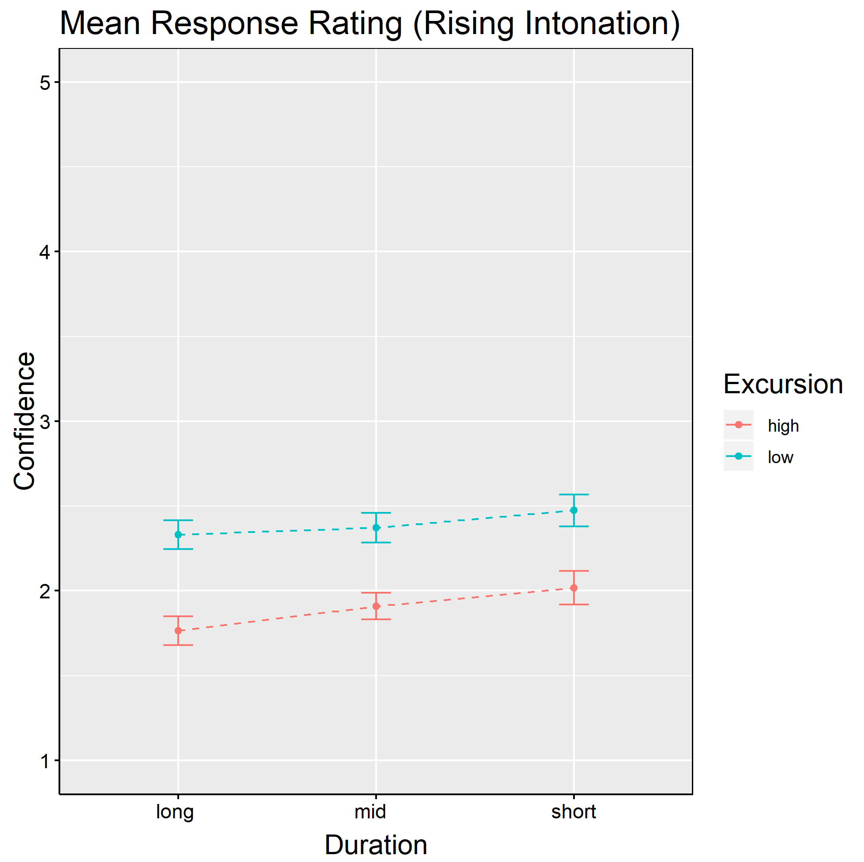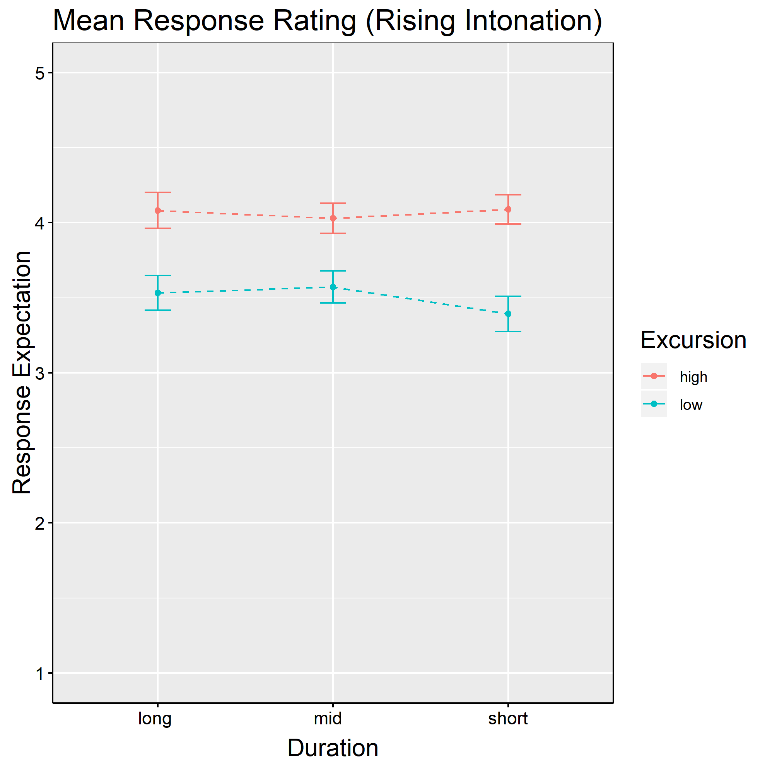

References
Bartels, C. (1997). Towards a Compositional Interpretation of English Statement and Question Intonation, Ph.D. thesis, University of Massachusetts Amherst, Amherst, MA
Beyssade, C., & Marandin, J. M. (2007). French intonation and attitude attribution. In Texas Linguistics Society Conference: Issues at the Semantics-Pragmatics Interface. Cascadilla Press.
Gunlogson, C. (2004). True to form: Rising and falling declaratives as questions in English. Routledge.
Pierrehumbert, J., & Hirschberg, J. (1990). The meaning of intonational contours in discourse. In: Cohen, P., Morgan, J., Pollack, M. (Eds.), Intentions in Communication. MIT P, Cambridge, MA, pp. 271–311.
Šáfářová, M.: 2006, Rises and Falls: Studies in the Semantics and Pragmatics of Intonation, PhD thesis, Institute for Logic, Language and Computation, Universiteit van Amsterdam.
Truckenbrodt, H. (2012). Semantics of intonation. In: C. Maienborn, K. von Heusinger & P. Portner (eds.), Semantics. An international handbook of natural language meaning. Vol. 3. Berlin: de Gruyter, 2039-2969.

L2 Acquisition of Nuclear Accent Placement in English
Stephanie Landblom
University of Illinois at Urbana Champaign

This study investigates L2 acquisition of English nuclear accent (NA) shift in different contexts. NA placement is subject to different grammatical constraints and pragmatic conditions (e.g. Ladd, 2008). For instance, sentences like those in (1), with a compound in final position contrast in NA placement with the segmentally identical sentences in (2), with an adjective+noun sequence, because compounds generally have initial prominence:
- They live in the White House / It is a toy factory
- They live in the white house / It is a toy factory
However, under contrastive stress, NA may also be retracted to the adjective in (2). Such distinctions have been shown to be difficult for L2 speakers to learn (Zubizarreta & Nava, 2011; van Maastricht et al, 2016).

Four categories of accent-retraction rules were included : (a) final vs. non-final stressed compounds, (b) contrastive focus on a non-phrase-final word, (c) left-stress compounds vs. adjective+noun sequences (d) unaccented indefinites in phrase-final position (e.g. I saw someone) and (e) sentences with intransitive verbs, in which NA placement is reportedly affected by both verb type (unaccusative vs unergative) and expectedness (Zubizarreta & Nava, 2011). The goal of this study is to examine how learners acquire NA shift in these categories, and to determine which may be more difficult to acquire.

To do this, both a native control group and a group of L1-Spanish/L2-English learners recorded series of sentences designed to elicit NA shift in the various categories. Measurements of pitch, intensity and duration were extracted to evidence NA placement. Additionally, participants completed an intuition task in which they indicated which word they perceived as having the greatest prominence. Finally, NA in each utterance of the production data was located by trained annotators.

Results from the production data indicate that native speakers made clear distinctions between final and retracted accent in the four categories (a)-(d) (Fig. 1). There was also a distinction in intransitives with unaccusative, expected verbs more likely to occur with subject accent than unergative verbs or then unexpected, unaccusative verbs (Fig. 2). These trends were supported by the intuition data. The L2 speaker group showed more variability with less of a clear distinction between final and retracted accent in all categories (Figs. 3 and 4). Overall, narrow focus and compounds were the most reliably produced, whereas intransitives and indefinite pronouns were the most difficult. These findings have implications for theories of L2 acquisition of prosody.

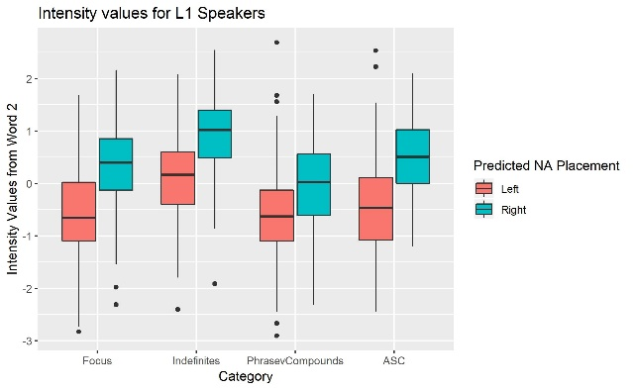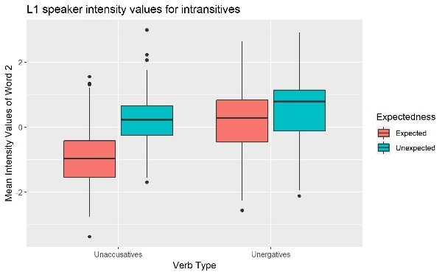
  - Fig 1: Intensity values for L1 speakers Fig. 2: L1 intensity values for intransitives

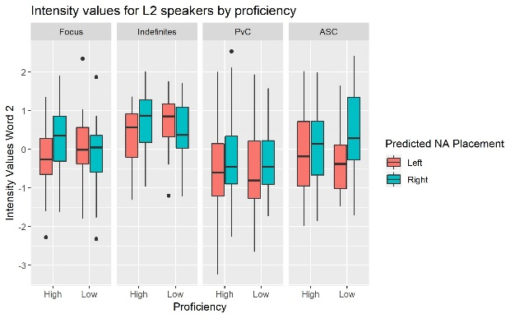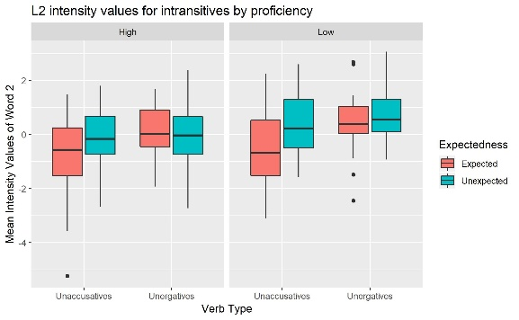
  - Fig. 3: L2 intensity values by proficiency Fig. 4: L2 intensity values for intransitives

References

Ladd, D. R. (2008). Intonational phonology. Cambridge University Press.
Maastricht, L., Krahmer, E., & Swerts, M. (2016). Prominence patterns in a second language: Intonational transfer from Dutch to Spanish and vice versa. Language Learning, 66(1), 124-158.
Zubizarreta, M. L., & Nava, E. (2011). Encoding discourse-based meaning: Prosody vs. syntax. Implications for second language acquisition. Lingua, 121(4), 652-669.

L2 acquisition of French accentual phrase by Persian learners:
Impact of L1 morphology
Shahrzad Mirzaei
University of Toronto
The aim of this study is to examine whether Persian speakers transfer some morpho-phonological stress properties from Persian (Farsi) to French L2 due to crosslinguistic influence. Although the French and Persian lexical prominence systems are extremely similar, the position of lexical prominence in inflected verbs differs between the languages. As in French, lexical prominence in Persian falls on the final syllable of nouns, adjectives and adverbs (Amini, 1997). Verbs in Persian are also stressed syllable-finally if their stem is not inflected (e.g., [xæriˈdæn] ‘to buy’). However, verb stems are often subject to at least one affixation (plural, person, negation, among others) that changes the placement of the conjugated verb’s prominence (e.g., [xæˈrid-æm] ‘I bought’). Thus, the position of prominence in verbal forms can be initial, medial or final, which contrasts with the fixed final prominence of the corresponding forms in French. For the purposes of this ongoing study, we aim to provide some answers to the following questions: (i) How do Persian-speaking learners of French realize accentual phrase in French? (ii) To what extent does the morpho-phonological constraints of the positioning of Persian stress system, especially in verbal structures, influence the acquisition of French accentual phrase in L2 French? (iii) Are the observed effects consistent across learners of different L2 proficiency?
This research project includes an experiment testing 40 adult participants (30 L1 Persian learners of three different proficiency levels and a control group of 10 native French speakers). Participants will complete a carrier sentence reading task. The data from this task will be further analyzed aurally and acoustically to evaluate (i) the position of the prominence in different morpho-syntactic L2 structures, (ii) the quality of the accented vowel and (iii) the duration of accented / unstressed syllables. The results of this study will help to determine the influence of crosslinguistic transfer in the acquisition of accentual phrase in L2 French and will contribute to our understanding of L2 prosodic production.
Reference
Amini, A. (1997). On stress in Persian. Toronto Working Papers in Linguistics, 16(1), 1-20.

Narrow focus prosody in Kazan Tatar
Adam Royer and Sun-Ah Jun
University of California, Los Angeles

This study reports focus prosody of Kazan Tatar, a Turkic language spoken in Tatarstan, Russia, as part of ongoing research investigating an Autosegmental-Metrical model of intonational phonology of Tatar [2]. Our aim is to look for phonological and phonetic properties of focus marking in Tatar, especially by examining the strategies of head marking, edge marking, (de)accentuation, as well as pitch range expansion/compression.

Data were collected in Tatarstan from 6 native Tatar speakers. Narrow focus declaratives were elicited by presenting the speakers with wh-question sentences (e.g. Who liked the apple? Mariam_{focus} liked the apple) or providing a contrasting context in Tatar. They were asked to read the sentence out loud as if speaking with a friend. Before producing focus data, speakers read the broad focus declarative counterparts, which were interspersed with other types of declarative sentences varying in length and syntactic complexity. Speakers repeated each utterance twice.

Results of the neutral declaratives examined in the current study support previous findings that, in basic SOV sentences, the stressed syllable (often the word-final syllable) of subjects and objects is marked by a rising pitch accent ([L+H*] or [H*]). However, verbs did not receive a pitch accent. Instead, its initial syllable, whether stressed or not, is optionally realized with a high tone ([Hi]), functioning as a prominence marking. In addition, the right edge of declarative sentences is marked by an Intonation Phrase (IP)-final low boundary tone ([L%]) (see Figure 1).

Results of focus declaratives show that the pre- or post-focus words tend to be deaccented, and if not, there is a strong tendency of substantially compressing their pitch range. A focused word was produced with either a [L+H*] or an [Hi], or with both [Hi] and [L+H*] (see Figure 2). The prevalence of the [Hi] as a focus marker further supports previous analyses that suggest it marks prominence at the left edge of a word/phrase (cf. similar to the [Hi] in French [1]).

Aside from the presence of the [Hi], subject and object focus is marked tonally in the same way as broad focus. Verbs, however, exhibit a very different contour. In addition to an [Hi] on the initial or second syllable of the verb, a [L+H*] is aligned with the stressed (sentence-final) syllable (see Figure 3), truncating the IP-final L% boundary tone. However, the final syllable is sometimes lengthened to accommodate the [L%] boundary tone, creating a LHL contour in one syllable.

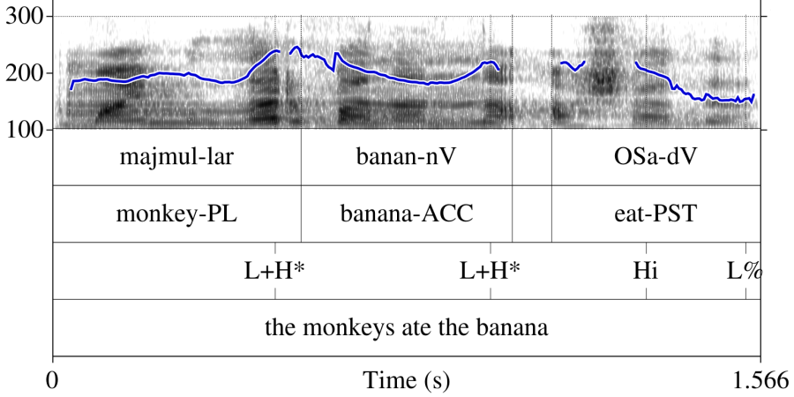

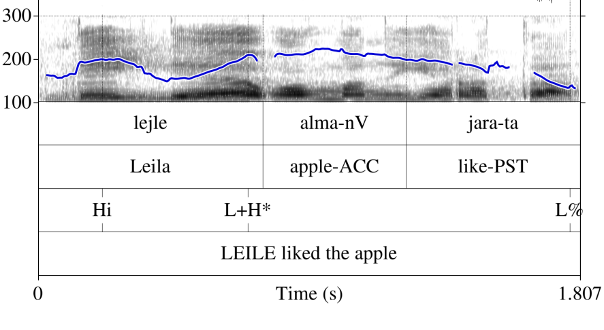
Figure 1: A sentence showing a neutral focus sentence with [L+H*]'s on the subject and objects, and an [Hi] on the second syllable of the verb.

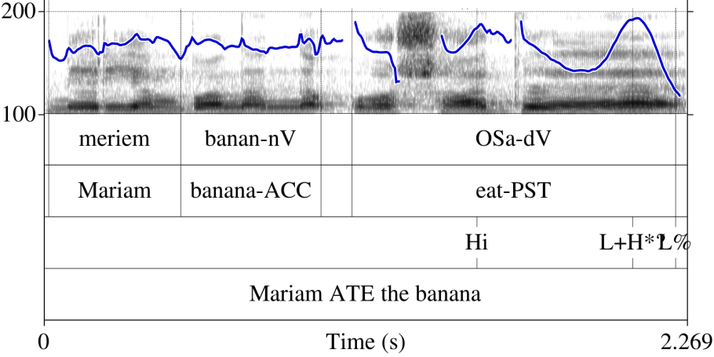
Figure 2: A sentence showing the [Hi L+H*] on the subject in narrow focus.

Figure 3: A sentence showing narrow focus on the verb and strong pitch compression on the subject and object.

[1] Jun, S. A., & Fougeron, C. (2000). A phonological model of French intonation. In Intonation (pp. 209-242). Springer, Dordrecht.
[2] Royer, A., & Jun, S. A. (2018). A Preliminary Model of Tatar Intonational Phonology. In Proc. 9th International Conference on Speech Prosody 2018 (pp. 769-773).

The Emphatic Juncture in English: A novel use of the IP boundary
Bethany Sturman
Department of Linguistics, University of California, Los Angeles

In American English, the Intonational Phrase (IP) is the largest prosodic phrase. The right edge of an IP is marked with a boundary tone (e.g. H%, L%), final lengthening, and a large juncture after the final word of the IP that may include a pause (Pierrehumbert, 1980; Beckman et al., 2005). In many cases, IP boundaries align with the edges of syntactic constituents (Selkirk 1986, among others). In some cases, however, speakers insert additional IP boundaries for information structural reasons, such as for narrow focus and contrastive topic marking (see Büring, 2003 for an overview.)

In this paper, I present evidence for another non-syntactic use of the IP boundary, the Emphatic Juncture (EJ), annotated on the Breaks tier as 4e. The EJ is found in various constructions such as transparent free relatives (e.g. in what some folks call a % silver tsunami, see (4)), partial quotation (e.g. Larry challenged an %“alarming rule”% at the board meeting, see (2)) (Sturman and Harris, 2018), and in various speech styles, such as sermon speech (3).

The EJ’s status as an IP-type boundary is clear from 1) significant final lengthening of the word directly preceding the boundary (e.g. an in (2)) and 2) the presence of a notable pause (sometimes >600 ms). The boundary tone sequence used to mark an EJ is a plateau (H-L%, !H-L%).

The EJ does not signal syntactic constituency. EJs can be inserted within the smallest syntactic constituents, such as between a determiner and noun (2) or between an adverb and its negation (3), and even word-internally (1). While it does not align to constituents, the EJ can be used to signal marked constructions such as partial quotation (2) and transparent free relatives (4).

Speakers employ the EJ to increase the prominence of material directly following the juncture. Although the EJ is often marked with a notable pause, it is intentionally planned by the speaker rather than a disfluency (i.e. not a ToBI 2 boundary type.) This intentionality is shown by the continuity of the pitch track across the boundary (2) as well as clear examples of downstep across the EJ boundary (1,3).

There is strong empirical evidence for another usage of the IP boundary, the Emphatic Juncture. While it employs many of the phonetic features of a canonical IP boundary, its discourse function is to highlight the following material as prominent rather than to mark syntactic constituency.

References:
Beckman, M. and Hirschberg, J. and Shattuck-Hufnagel, S. 2005. The original TOBI system and the evolution of the ToBI framework. In Sun-Ah Jun (ed.), Prosodic Typology: The Phonology of Intonation and Phrasing. 9-54. Oxford: Oxford Univ. Press.
Büring, D. (2003). On D-trees, beans, and B-accents. Linguistics and philosophy, 26(5), 511-545.
Pierrehumbert, J. B. (1980). The phonology and phonetics of English intonation (Doctoral dissertation, Massachusetts Institute of Technology).
Selkirk, E. (1986). On derived domains in sentence phonology. Phonology, 3, 371-405.
Sturman, B. and J. Harris (2018). Effect of partial quotation and transparent free relatives on perspective shift. 2nd meeting of the CAMP, Los Angeles, CA.

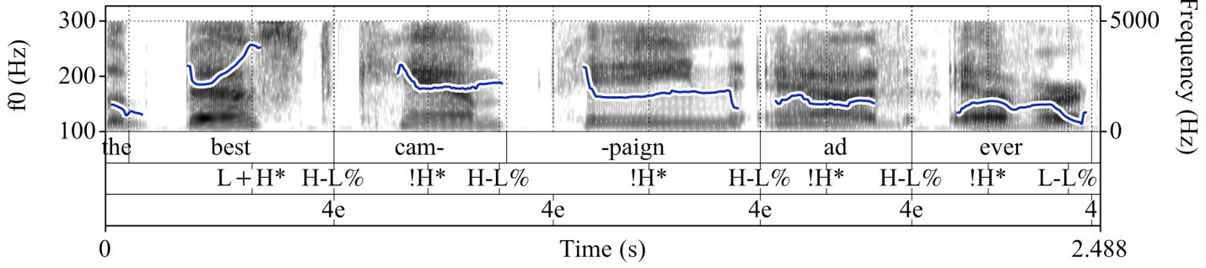
(1) Example showing word-internal Emphatic Juncture and downstep across EJ (from National Public Radio corpus)
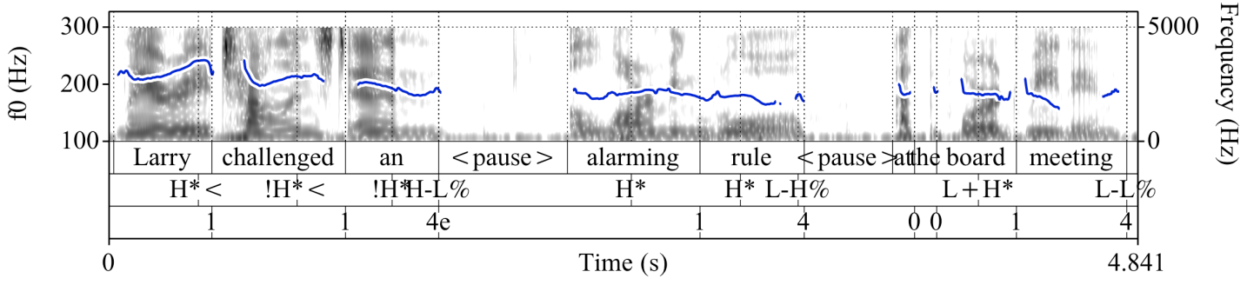
(2) Example showing continuity of pitch track (from Sturman and Harris (2018), an experiment investigating perspective shift in Partial Quotation and Transparent Free Relatives)

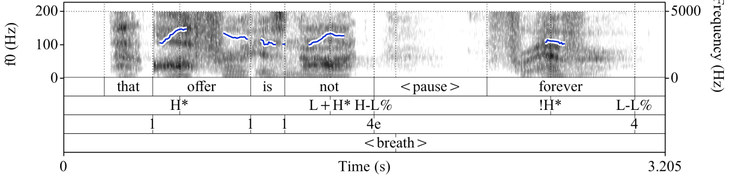
(3) Example showing downstep across an EJ (from sermon speech)
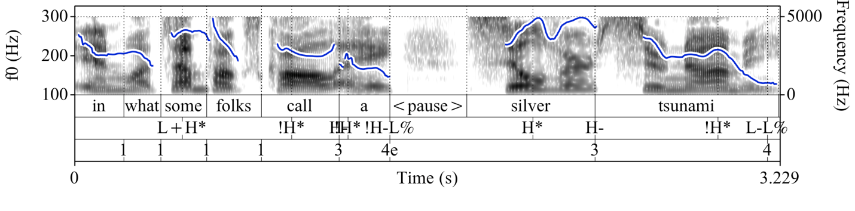
(4) Example of an Emphatic Juncture between a determiner and a noun (from National Public Radio corpus)
Contact-induced intonation change in Venezuelan Spanish speakers
living in Canada
Natasha Swiderski¹, Celina Valdivia¹, Yasaman Rafat¹, and Rajiv Rao²
¹Western University, ²University of Wisconsin-Madison

Whereas most studies on first language (L1) change have worked on morpho-syntactic change in contact situations (e.g., Montrul 2004; Rothman, 2012), less is known about L1 phonetic and phonological change (e.g., Celata & Cancila, 2010; Rafat, Mohaghegh & Stevenson, 2017). Moreover, although some recent studies have looked into intonation change in heritage speakers (e.g., Rao, 2016) very little is known about L1 intonation change in late sequential bilinguals (LSB). Crucially, age of acquisition and length of residence have been identified as two factors affecting the degree of L1 change in bilinguals (e.g., Nagy, 2015; Rao, 2016). Building on the aforementioned areas, the current study examines L1 intonation change in the nuclear configurations of yes-no questions in the Spanish (SP) of Caracas (Venezuela) SP-English LSB who moved to Canada in adulthood. While the intonation of yes-no questions in Canadian English (CE) has a final rising contour (Séguinot, 1976), unlike many varieties of SP (Escandell 2017), the Caracas dialect shows a final falling pattern (Sosa 1999). The rising versus falling contrast between CE and Caracas SP yes-no questions allows for exploring whether L1 intonational modifications occur in LSB as a result of language contact

The participants consisted of six adult CE-dominant LSB who have lived in Canada for at least five years and are originally from Caracas, Venezuela. Participants were presented with twenty hypothetical scenarios which elicited scripted, target questions that speakers produced in a manner they estimated as pragmatically appropriate (following Prieto & Roseano 2010). Two hundred utterances were analyzed through the Autosegmental Metrical Model (Pierrehumbert 1980; Ladd 2008) and the Spanish Tones and Break Indices (Beckman et al. 2002; Face & Prieto 2007; Hualde & Prieto 2015; Elvira-García, Roseano, Fernández Planas, & Martínez Celdrán, 2016). They were also asked to fill out a bilingual language profile (BLP; Birdsong, Gertken & Amengual, 2012) to measure dominance of language.

The results (analysis is still in progress) indicate transfer across both languages. There is a mixing of SP and CE which is trending towards a new “other” (i.e, hybrid) category, with similar patterns found across both languages. In the SP nuclear pitch configurations, the results show: 80% hybrid category, 9% caraqueño and 11% CE. The CE results showed: 48% hybrid category, 48%, CE influence was 43% and 3% caraqueño. We hypothesize this is due to the simplification of the Canadian pitch accents and a mixing of the boundary tones.

References

Beckman, M., Díaz-Capos, M., McGory, J.T., & Morgan T.A. (2002). Intonation across Spanish, in the Tones and Break Indices framework. Probus, 14(1), 9-36
Birdsong, D., L.M. Gertken & M. Amengual. (2012) Bilingual Language Profile: An Easy-to- Use Instrument to Assess Bilingualism. COERLL, University of Texas at Austin. <https://sites.la.utexas.edu/bilingual/>.
Celata, C., & Cancila, J. (2010). Phonological attrition and the perception of geminate consonants in the lucchese community of san francisco (CA). International Journal of Bilingualism, 14(2), 185-209.
Colantoni, L., Cuza, A. & Mazzaro, N. (2016) Task related effects in the prosody of Spanish heritage speakers. In Amstrong, M., Henrikssen N., Vanrell M. (Eds) Intonational Grammar in Ibero-Romance. Amsterdam: John Benjamins, pp. 3-24.
Face, T. L. (2004). The intonation of absolute interrogatives in Castilian Spanish. Southwest Journal of Linguistics, 23(2), 65-80.
Elvira-García, W., Roseano, P., Ferdández-Planas A. M., & Martínez-Celdrán, E. (2015), A tool for automatic transcription of intonation: Eti_ToBI a ToBI transcriber for Spanish and Catalan. Language Resources and Evaluations, 50(4), 767-792. doi: 10.1007/s10579- 015-9320-9.
Escandell-Vidal, V. (2017). Intonation and evidentiality in Spanish polar interrogatives. Language and Speech, 60(2), 224-241.
Hualde, J. I., & Prieto, P. (2016). Towards an international prosodic alphabet (IPrA). Laboratory Phonology, 7(1), 5. doi:10.5334/labphon.1
Isurin, L. (2007). Teachers' language: L1 attrition in Russian-English bilinguals. The Modern Language Journal, 91(3), 357-371. doi:10.1111/j.1540-4781.2007.00585.x
Ladd, D. R. (2008). Intonational phonology (2nd ed.). Cambridge;New York;: Cambridge University Press.
Leeuw, E. D., TUSHA, A., & SCHMID, M. S. (2018). Individual phonological attrition in albanian-english late bilinguals. Bilingualism, 21(2), 278. doi:10.1017/S1366728917000025
Montrul, S. (2004). The acquisition of spanish: Morphosyntactic development in monolingual and bilingual L1 acquisition and adult L2 acquisition. Amsterdam;Philadelphia;: J. Benjamins Pub.
Nagy, N. (2015). A sociolinguistic view of null subjects and VOT in Toronto heritage languages. Lingua, 164, 309-327. doi:10.1016/j.lingua.2014.04.012
Pascual y Cabo, D. & J. Rothman. (2012). The (il)logical problem of heritage speaker bilingualism and incomplete acquisition. Applied Linguistics 33(4): 1-7.
Pierrehumbert, J. B. (1980). The phonology and phonetics of English intonation (Doctoral dissertation, Massachusetts Institute of Technology).
Prieto, P. & P. Roseano. Transcription of intonation of the Spanish language. Munich: LINCOM Europa.
Rafat, Y., Mohaghegh, M., & Stevenson, R. (2017). Geminate attrition across three generations of Farsi-English bilinguals living in Canada: An acoustic study. Ilha do Desterro, 70(3), 151-168. doi:10.5007/2175-8026.2017v70n3p151
Rao, R. (2016). On the nuclear intonational phonology of heritage speakers of Spanish. In Advances in Spanish as a Heritage Language, ed. by D. Pascual y Cabo, 51-80. Amsterdam: John Benjamins.
Rothman, J., & Guijarro-Fuentes, P. (2012). Linguistic interfaces and language acquisition in childhood: Introduction to the special issue. First Language, 32(1-2), 3-16. doi:10.1177/0142723710396794
Séguinot, C.L.C. (1976). Some aspects of the intonation of yes-no questions in Canadian English (Doctoral dissertation). Retrieved from ProQuest Dissertations and Theses Global. (Order No. NK35127).
Sosa, J.M. (1999). La entonación del español. Su estructura fónica, variabilidad y dialectología. Madrid: Cátedra

A phonetic study of the relation between subglottal pressure and intonation in French declarative sentences
Ruolan Wang¹, Sergio Hassid², Philippe Martin³⁴ and Didier Demolin¹
Laboratoire de phonétique et phonologie, UMR 7018, Sorbonne nouvelle, Paris 3¹ Hôpital Erasme, Université Libre de Bruxelles², LLF Paris Diderot³,
Department of French U of Toronto⁴

In French the most important global attribute of declarative sentences is a declination of F0 decreasing slowly from an initial rise on the second syllable to the end. Attempts have been made to make a distinction between programmed voluntary F0 changes and physiologically determined, involuntary fluctuations. A crucial issue in this perspective is therefore to know if declination is programmed and voluntary or not. So far no clear-cut solution has been found to this question.

The presentation paper addresses this issue by studying the relation between F0 declination and subglottal pressure (Ps) decrease in a set of 8 French declarative sentences produced by 3 native French speakers (2 men and 1 woman). Ps and F0 were recorded simultaneously and Ps was measured by direct tracheal puncture. Each sentence was repeated 3 times by each speaker. Data have been recorded with a Physiologia workstation and processed with Phonedit and Winpitch software.

‘ t Hart, Collier and Cohen (2006) suggested that the ratio between the F0 and Ps changes is accounted for as 3 to 7 Hz/hPa (Ps was measured in hecto Pascal, 1 hPa = 1,2 cm H₂O). They also proposed that it seems justified to consider the decreasing subglottal pressure as the primary source for F0 declination. However they later nuanced their claim when saying that it is not always and exclusively Ps that causes the F0 declination.
Our results show that the ratio proposed by ‘t Hart et al. (2006) is valid only if it is 7Hz/hPa but sometimes it must imply larger F0 values. This suggests that the relation between F0 and Ps declination is not as tight as what was proposed by ‘t Hart et al. (2006). Results also show that Ps declination when it exists between Ps initial rise and final falls, is weak. Results are similar for our 3 subjects, ∆ max/min for Ps = 2.6 hPa in our data. The F0 baseline relating the utterances mid and final parts of the first and last vowels shows an average ∆ comparable for both men (16 Hz). F0 ∆ on the baseline is larger for the woman subject as expected.

Reference

‘t Hart, J, Collier, R. and A. Cohen (2006). A perceptual study of intonation. An experimental-phonetic approach to speech melody. Cambridge, Cambridge University Press.

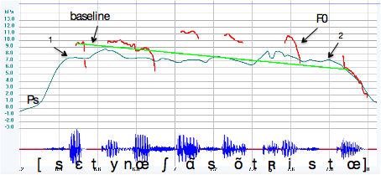
Figure 1. Ps, Fo curves and baseline for the sentence ‘c’est une chanson triste’ [sɛtynœʃɑ̃sõtʀ̥istœ]. 1 indicates the end of the Ps initial rise and 2 the beginning of the Ps final fall that are taken to measure Ps declination. The baseline is measured from the mid part of the initial vowel to the mid part of the final vowel.

Reporting on joint work with Dan Goodhue, University of Maryland

